October Newsletter 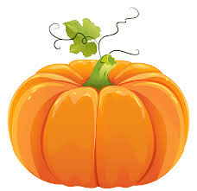
Dear Parents;
It’s hard to believe its October already, but the leaves changing color and falling from the trees serve as a reminder that the seasons continue to march on. October will be a great month full of learning opportunities and exciting events.
What We Are Looking at This Month:  In September we looked at the “4-Bs” and friendships. If you are unsure what the “4-Bs” are, just ask your child they should know them by heart.  In math, we have been counting and working on subitizing. This month we will be looking at number patterns and what makes a pattern. We will continue to look at the recognition of numerals and counting objects effectively. We will also be doing some graphing.  In phonics, we have been thinking about letters and the sounds they make as well as blending those sounds to make simple words. We have also been focusing on how to print those letters properly. There are some words that are important to memorize so that reading can be done smoothly and effectively. These words are called sight words. I will periodically send home a list of those sight words. Please practice these words by having your child print them and say them so that he or she knows that word by heart. We will be looking at “Just Right Books” and how to pick an appropriate book for your own level. | Corn Maize  Field Trip  We will be going to the Corn Maize on Monday October 22nd. We welcome volunteers. If you are interested in coming along on this trip and you have completed a criminal records check, please let me know.  Black and Orange Day: October 30th is Black and Orange Spirit Day. Children are encouraged to dress up in black and orange. It can be as simple as an orange t-shirt or as fancy as orange and black hair, or face makeup.  Proper Shoes:  The weather is changing and the children need to come to school with proper shoes. We will still be doing the School Wide Run on cool days so coats are important as well. If your child has trouble tying laces, please practice with him or her at home or send them with velcro shoes.
Some Reading Strategies to use with your Child:  Please remember that it is good for your child to read books that are generally easy with only a few words that he or she need to use a reading strategy to figure out. If a book is too difficult it can lead to frustration and a perception that reading is too much work.  A few strategies that we will be learning in class are:  • Looking at the pictures is a great way to figure out what a word might be.  • Have your child get his or her mouth ready to say the first letter sound.  • Ask your child “What would make sense in this sentence?”  • Go on and come back to the word. Sometimes there are clues in the rest of the sentence that will help.  • Look for letter “chunks” in the word that he or she might know.  • Read to your child material that might be too difficult and encourage him or her to follow along, looking for words he or she already knows.  • It is beneficial for your child read the same book over and over again. You might get bored with it, but he or she is learning spelling patterns and word recognition.  • Easy books are also beneficial as long as he or she is choosing some books with a small challenge. | Volunteers:  If you are interested in volunteering in the classroom, please write a note to me telling me what sorts of things you would be interested in and what times are good for you. I need parents to help with Home Reading Books. Those volunteers exchange books that the students take home each night. I often need helpers for field trips. Your interest in helping on the field trip would be expressed on the permission form that will come home with your child. Reading is another excellent opportunity for you to help in the classroom. Children can always use another person with which to practice their reading skills.  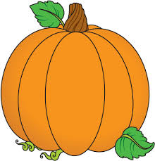

Some Dates to Remember:
October 12th Thanksgiving Day – no school
October 22nd Field trip to Corn Maze
October 23rd Provincial Wide Professional Day – no school
October 30th Black and Orange Spirit Day
Please feel free to contact me at the school with any questions you might have. Have a great week!

Sincerely,
Mrs. C. Hartman

